### DATABASE MANAGEMENT SYSTEM

### CSE-2004

### REVIEW-III



**TEAM MEMBERS:**

**ANUVAB DUTTA (19BCE0603)**

**AVIROOP NANDY (19BCE0246)**

**VISHNU KALRA (19BCE0374)**

1. ABSTRACT:

Our project "Faculty Review System" is to show that a connection can be achieved between the faculty and students. This project has two main goals, firstly it is an easier way to select faculty during course registration based on the reviews given by the other students. Secondly, this system would help the faculty to change their teaching methods.

1. INTRODUCTION:

This system provides a better way for students to choose their type of faculty over a wide range of faculty members. Firstly students will have to create a username and password to login to the system. Then the students can choose the option to feedback the faculty and they have to select the course code, course name, and then give the faculty a review. The institution provides the students to choose their faculty and some students face problems in choosing their faculties so this system cancels that problem.

1. BREIF DESCRIPTION:

There is going to be an admin where the username and password are given to both faculty and students. Students are given an option to write a review. This system is where students can write a review of the faculty. The student must mention their registration number, name, date of birth, course, e-mail, password, etc. but the faulty cannot view the student who wrote the review. The faculty should also mention their id, name, mobile number, course code, and password. The students can even change their review of their respective faculty which will be sent directly to the management.

1. EXISTING SYSTEM:

The current system has the facility for students to provide reviews for a particular teacher and that teacher can see the reviews. But there is no facility for students to log in and see the reviews of teachers given by other students.

1. NOVELTY OF OUR PROJECT:

We made the facility for the students as well as, teachers to log in to the system and see the reviews given to the teachers by others. In this way, the students get proper idea about the teacher before choosing and also the teachers can improve their teaching methods accordingly.

1. ER DIAGRAM:

The Entity-Relation Diagram for our project is given in Figure 1. This diagram contains all the tables that we have used in the database, along with the relations they shared with the other tables.

The tables are Admin, Student, Faculty and Feedback and the relationships are between them. And Each Entity has different attributes.

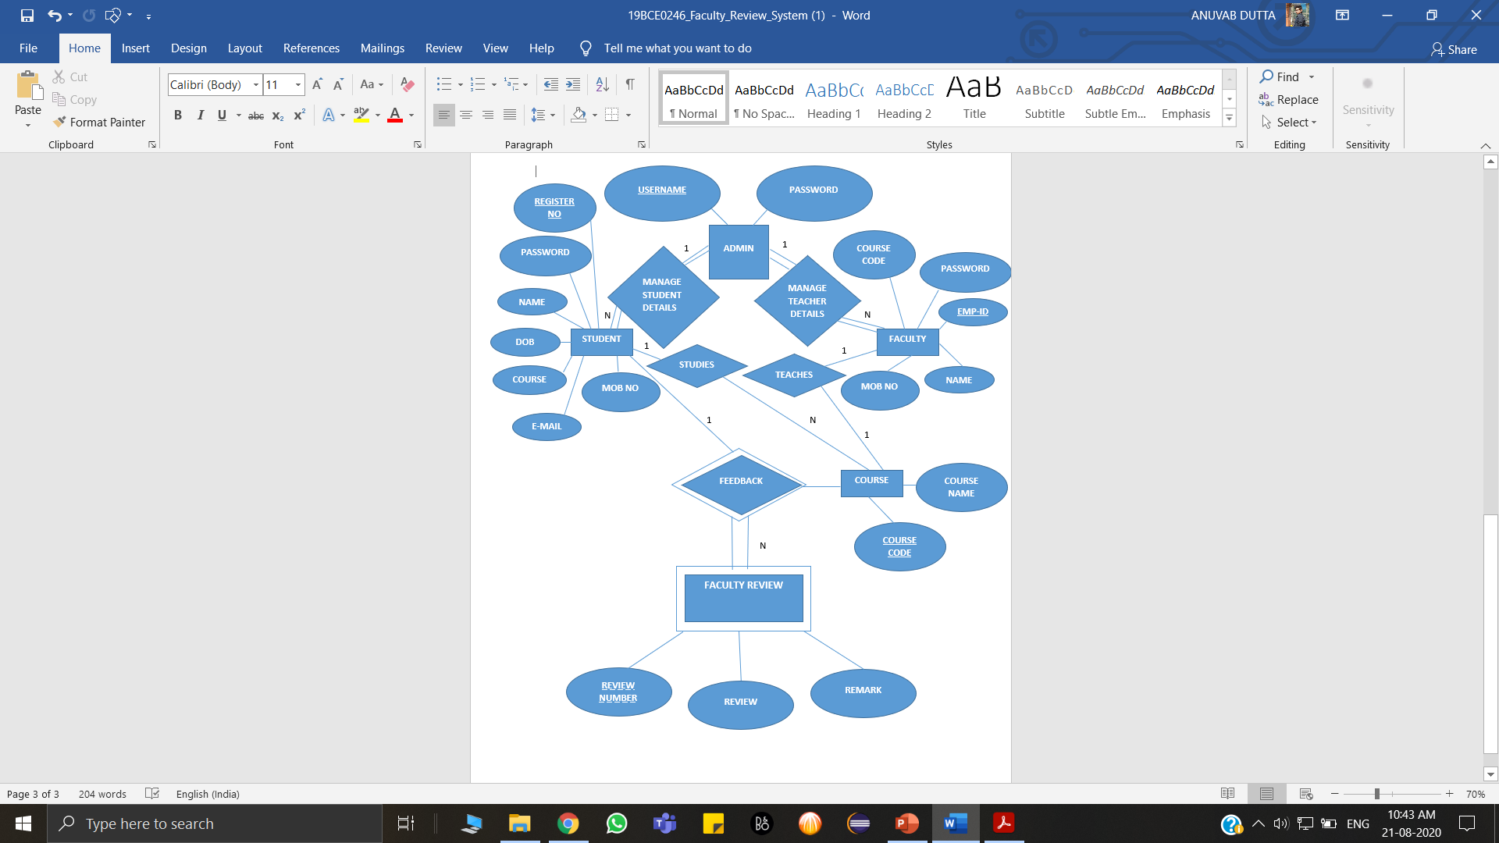

Figure 1: ER Diagram for Faculty Review System

1. SCHEMA DIAGRAM:

The Schema Diagram for our project is shown in Figure 2. It provides an overview of the database, while facilitating future administrator’s work. This makes making of database more efficient.

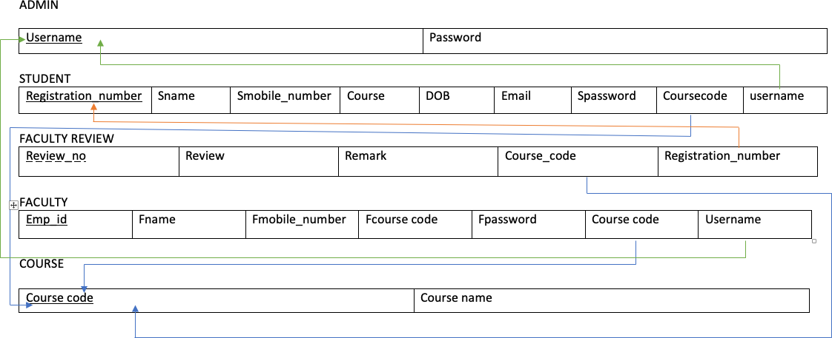Figure 2: Schema Diagram for Faculty Review System

1. TOOLS REQIURED:
2. Front-End:
3. NETBEANS
4. JAVA
5. Back-End:
6. PHP
7. MySQL
8. Connecting Back-End and Front-End:
9. JDBC
10. FRONT-END SCREENSHOTS:

Given below (Figures 3 to 16) are the screenshots for the front end portal:

STUDENT PORTAL:

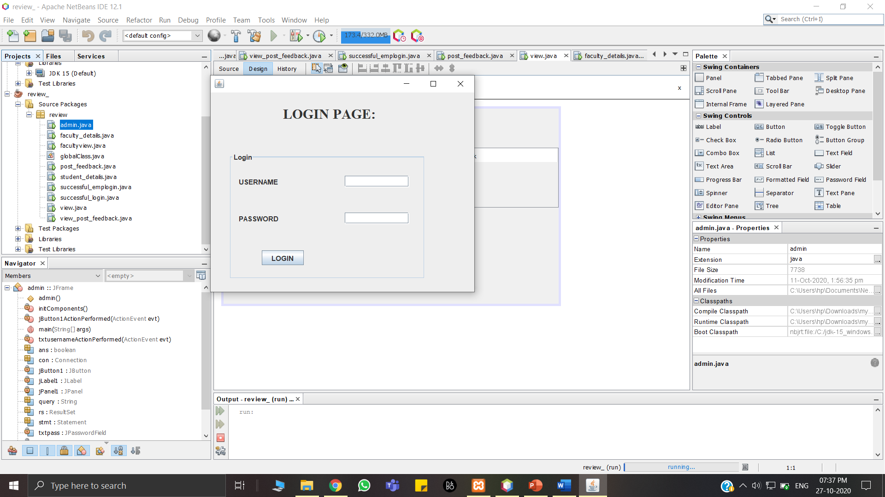

Figure 3: Student Portal

This Figure 3 is the opening page of our project. In this we need to provide the system with valid username and password. Students need to provide students’ id and their password.

ENTERING STUDENT DETAILS:

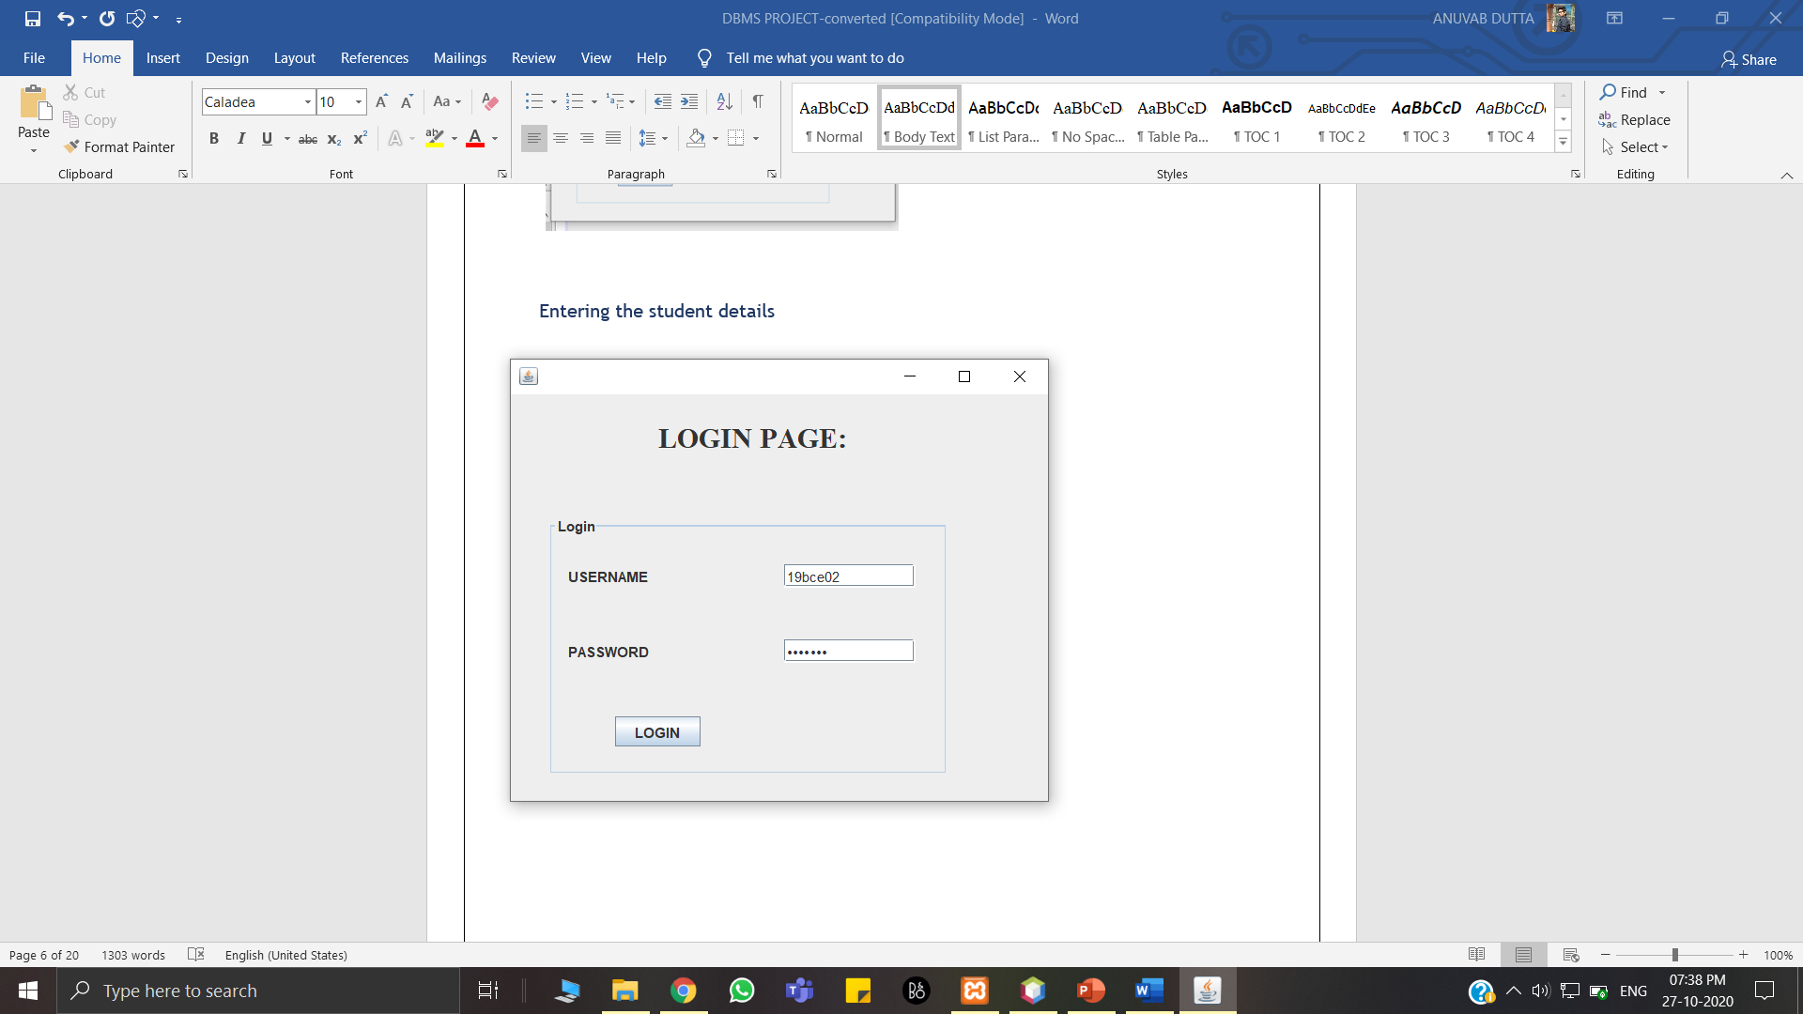

Figure 4: Student Login Page

This Figure 4 is shows insertion of proper Student id and password shown as ‘ * ’ for security purposes. Then the student needs to press the ‘Login’ button.

AFTER ENTERING STUDENT DETAILS CORRECTLY:

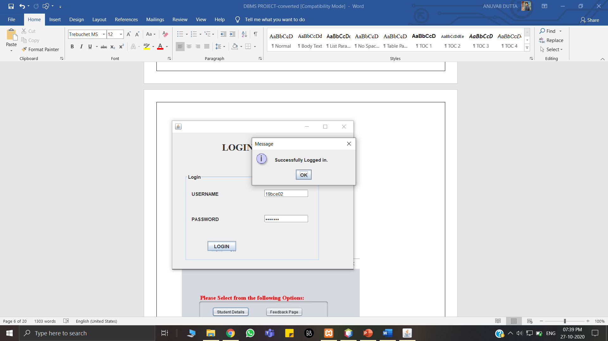

Figure 5: Login Successful

This Figure 5 shows the message “ Successfully Logged in.” when the Username and password match as present in the Student Table in the database. Then Press “OK” to move to next page.

AFTER SUCCESSFUL LOGIN OF STUDENT PORTAL:

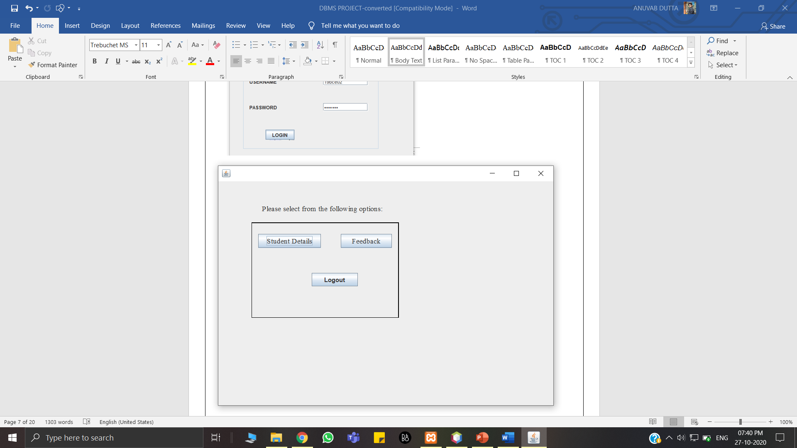

Figure 6: Student Details/Feedback

This Figure 6 gives 2 options to choose from “Students Details” and “Feedback“ or if you want to logout , then press “LOGOUT” button.

ON CLICKING ‘STUDENT DETAILS’:

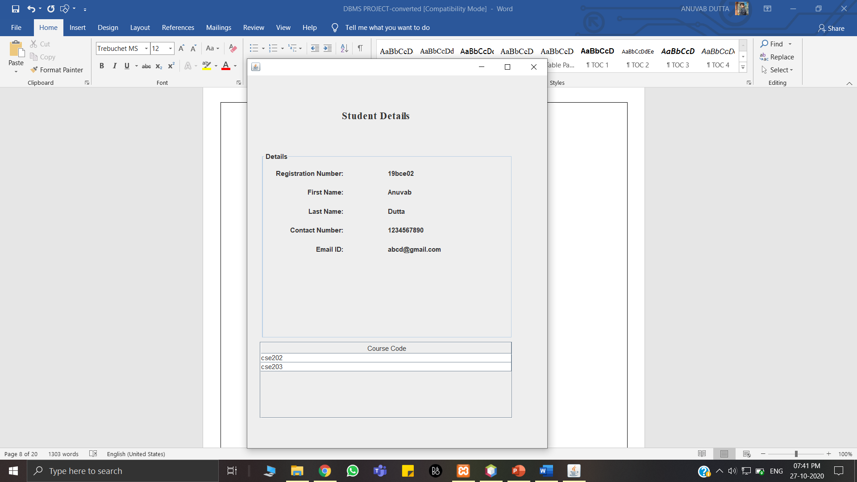

Figure 7: Student Details Page

This Figure 7 shows the details of the student, like First name, Last name, Contact number, Email ID And Courses by fetching it from the database.

ON CLICKING ‘FEEDBACK’:

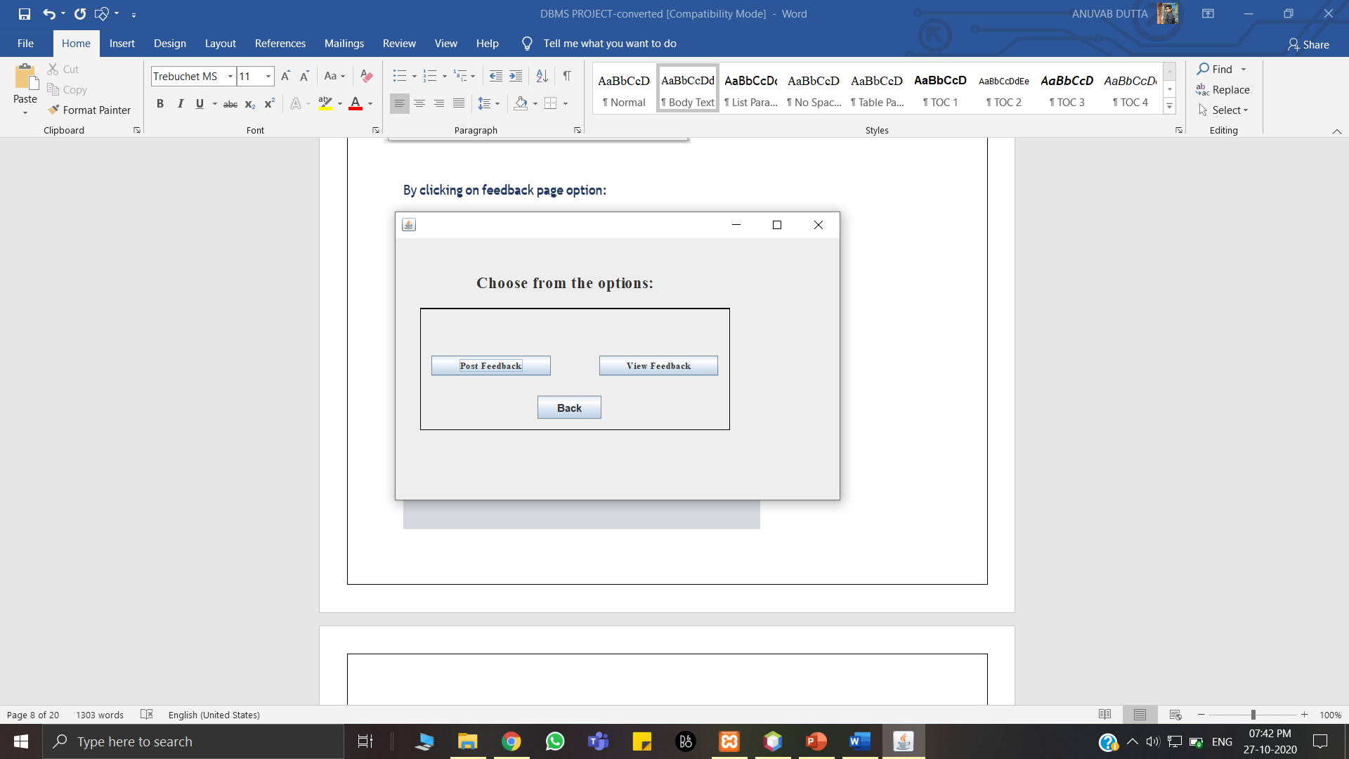

Figure 8: Student Feedback Page

This Figure 8 allows the student to either post his/her feedback in “Post Feedback” or view the feedback provided by other students in “View Feedback”.

ON CLICKING ‘POST FEEDBACK’:

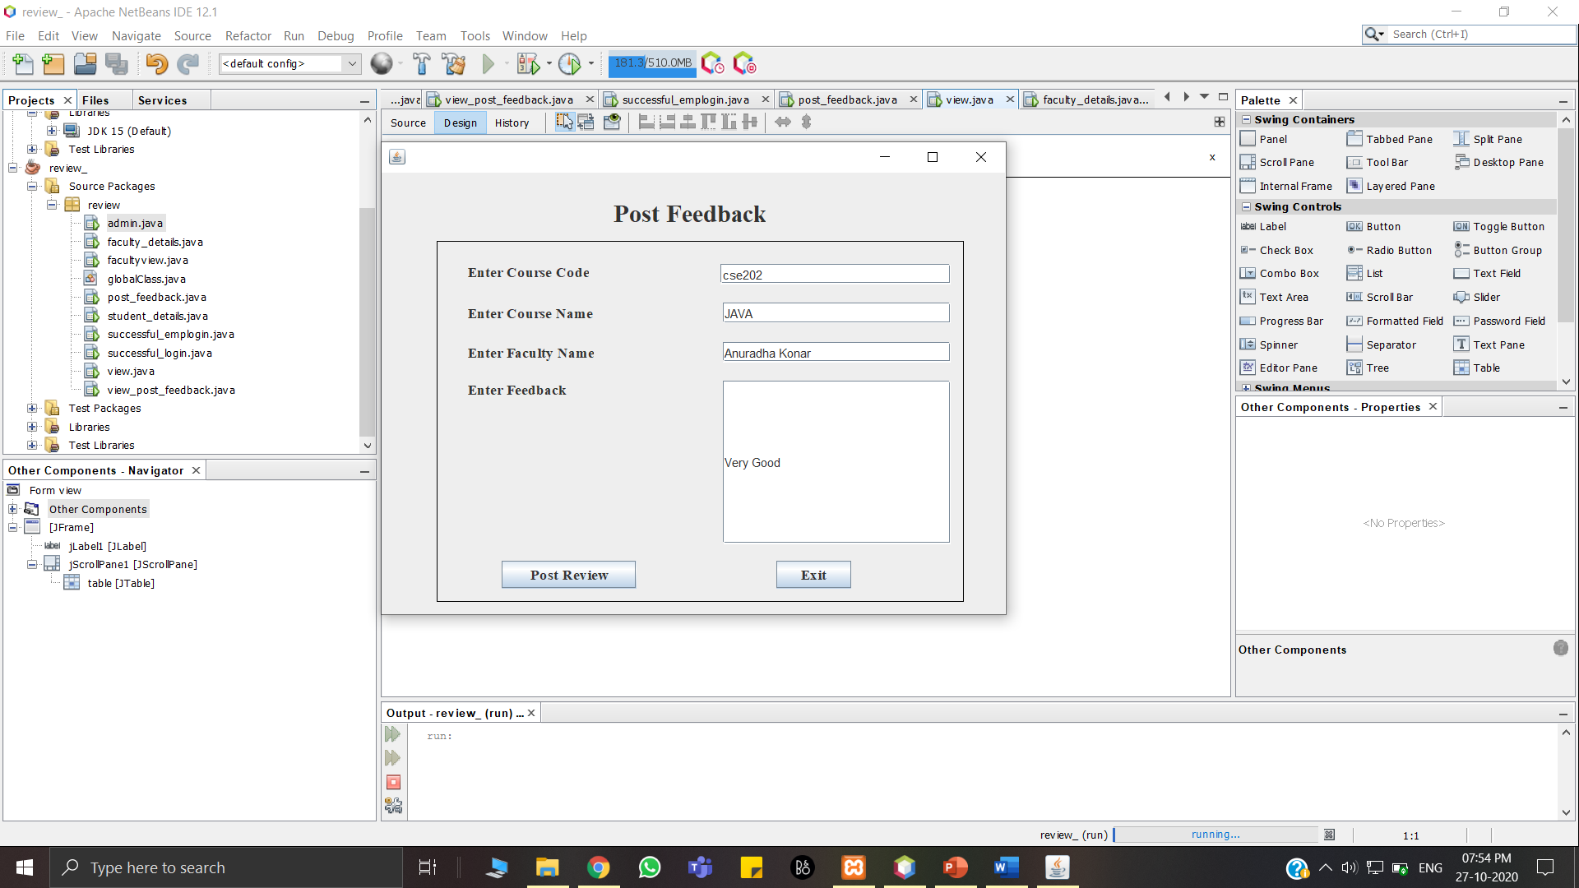

Figure 9: Student Post Feedback Page

This Figure 9 is the page where students can post their feedback by giving proper course code, course name, Faculty name and Feedback.

ON CLICKING ‘VIEW FEEDBACK’:

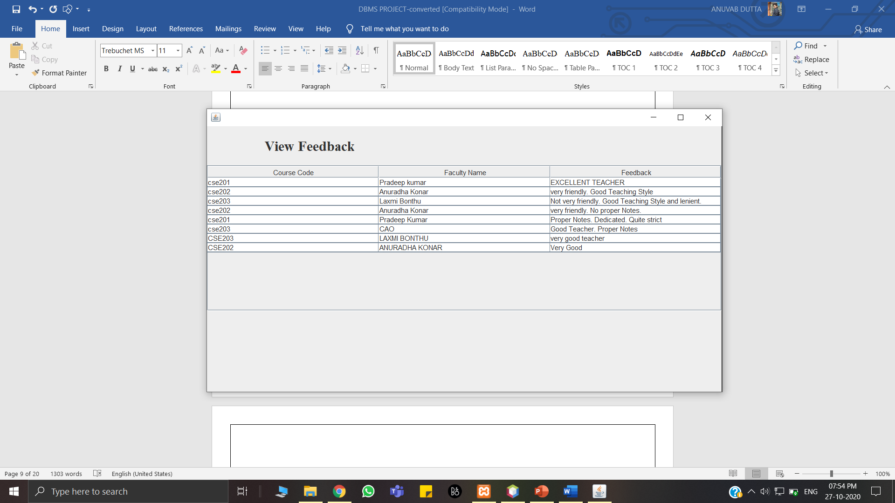Figure 10: Student View Feedback Page

This Figure 10 is the page where students can view the feedback posted by other students. This helps them choose the best teacher for them.

FACULTY PORTAL:

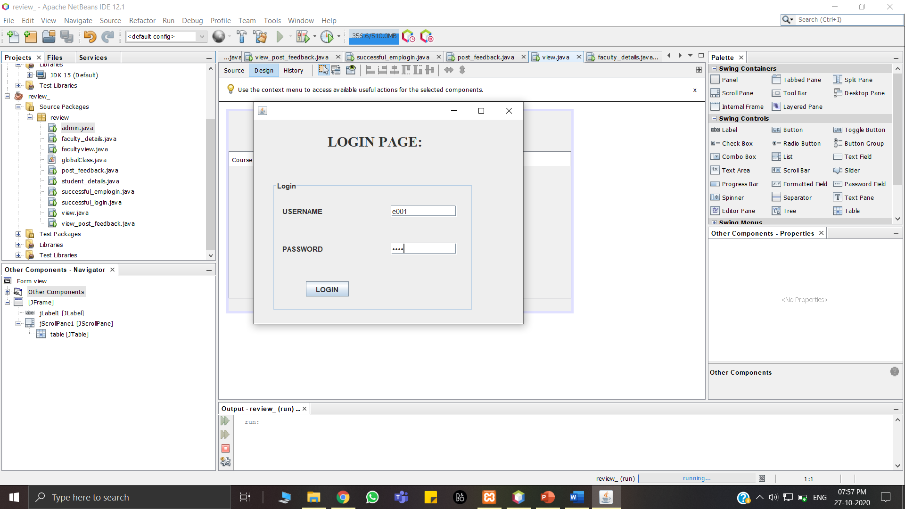

Figure 11: Faculty Login Page

This Figure 11 is the opening page of our project. In this we need to provide the system with valid username and password. Faculties need to provide Faculties’ id and their Password.

AFTER SUCCESSFUL LOGIN OF FACULTY PORTAL:

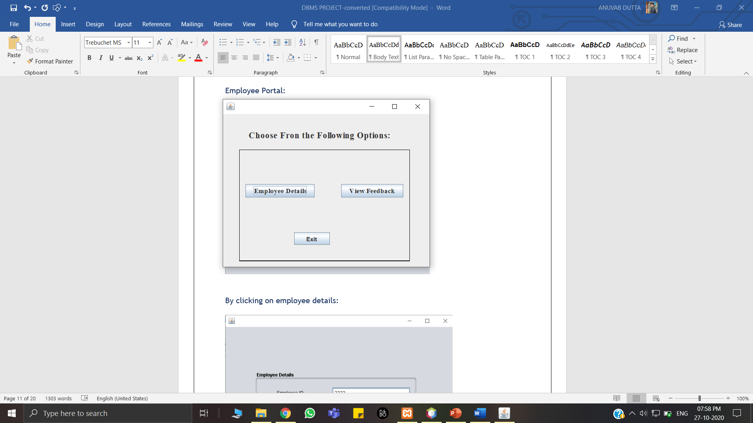

Figure 12: Faculty Details/View Feedback Page

This Figure 12 gives 2 options to choose from “Employee Details” and “View Feedback“ or if you want to logout , then press “EXIT” button.

ON CLICKING ‘EMPLOYEE DETAILS’:

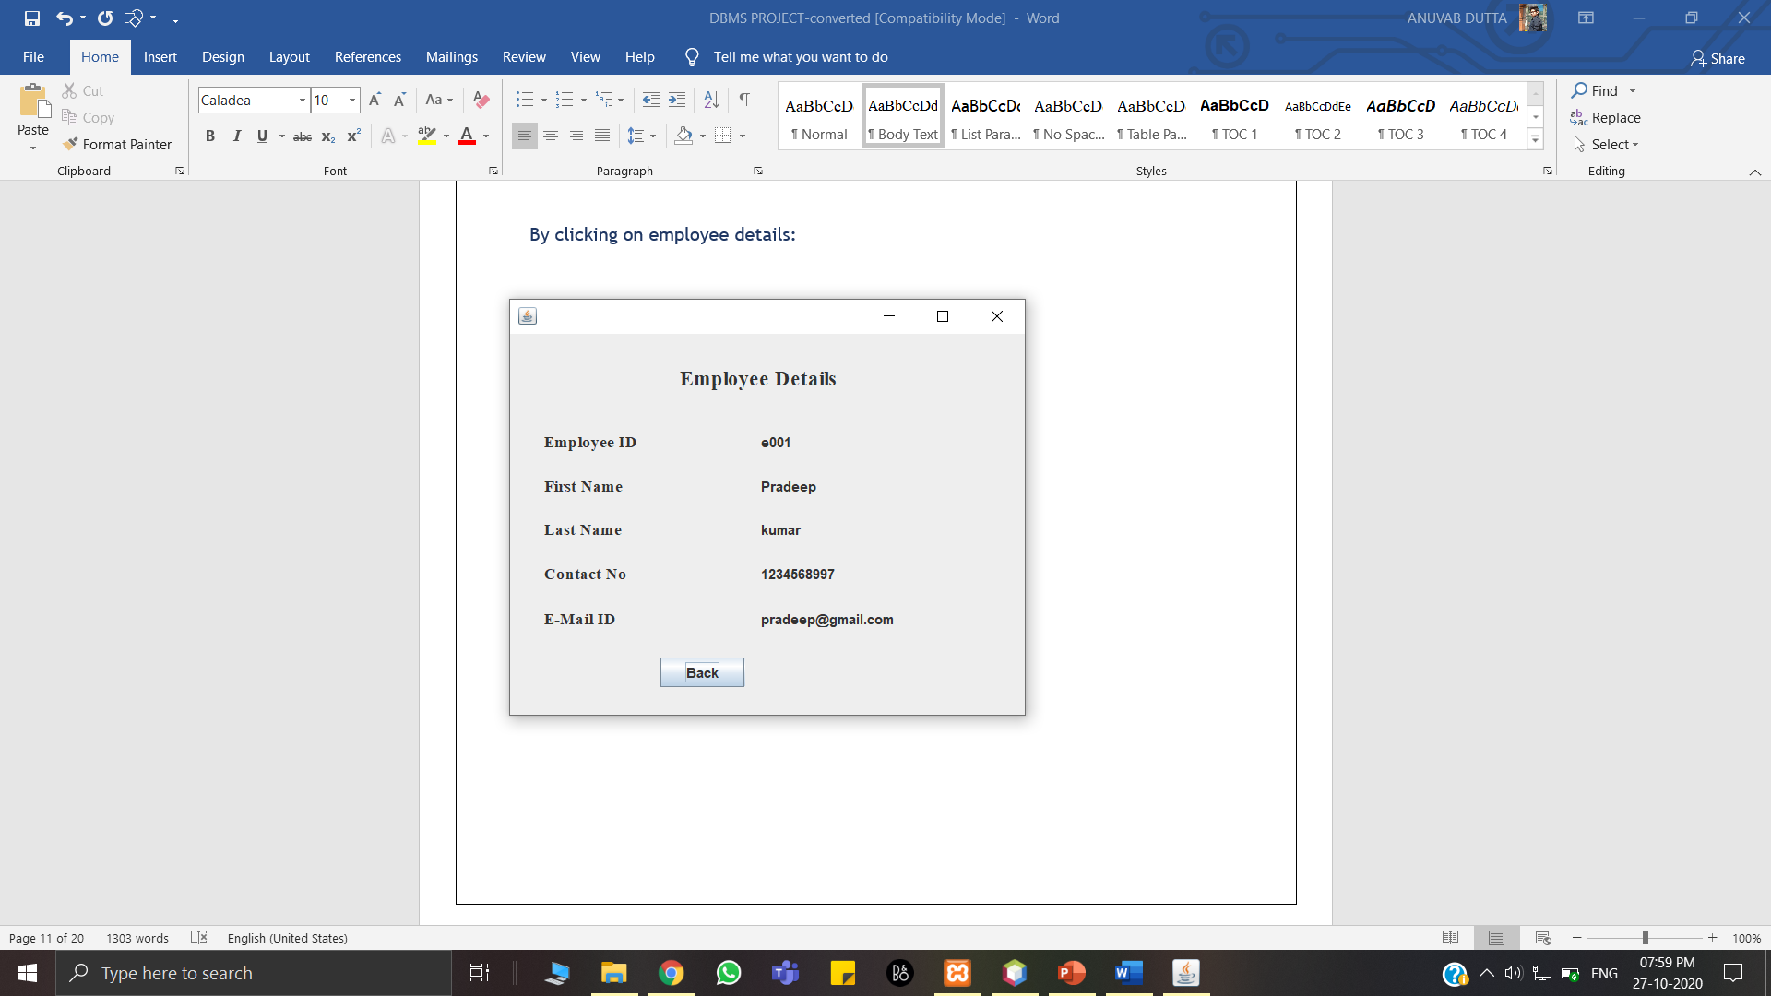

Figure 13: Faculty Details

This Figure 13 shows the details of the Faculty, like First name, Last name, Contact number, Email ID And Courses by fetching it from the database.

ON CLICKING ‘VIEW FEEDBACK’:

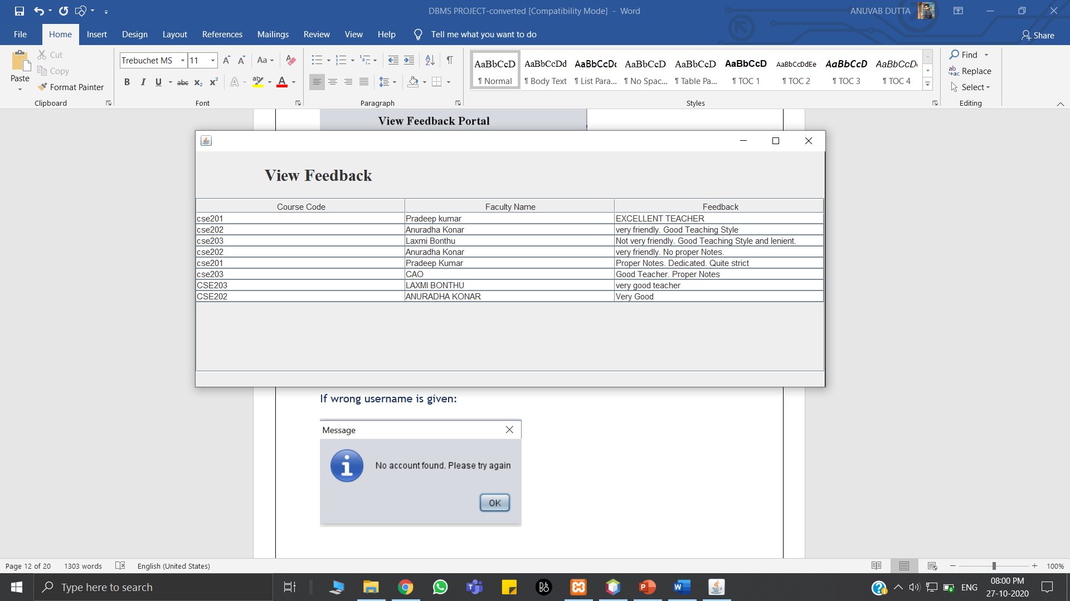

Figure 14: Faculty View Feedback Page

This Figure 14 is the page where Faculty can view the feedback posted by students.

ON ENTERING WRONG CREDENTIALS:

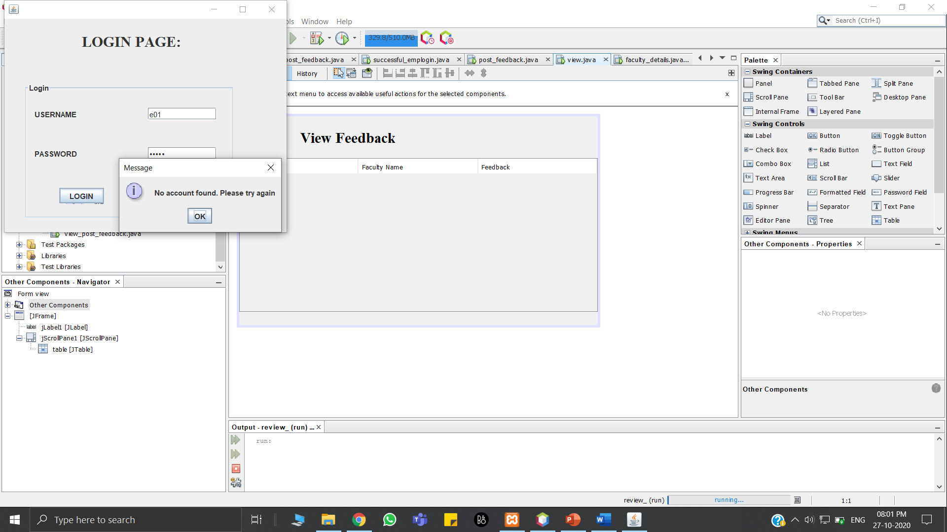

Figure 15: Invalid Credentials in Login Page

This figure 15 shows the error message if wrong username is given.

IF THE PASSWORD IS WRONG:

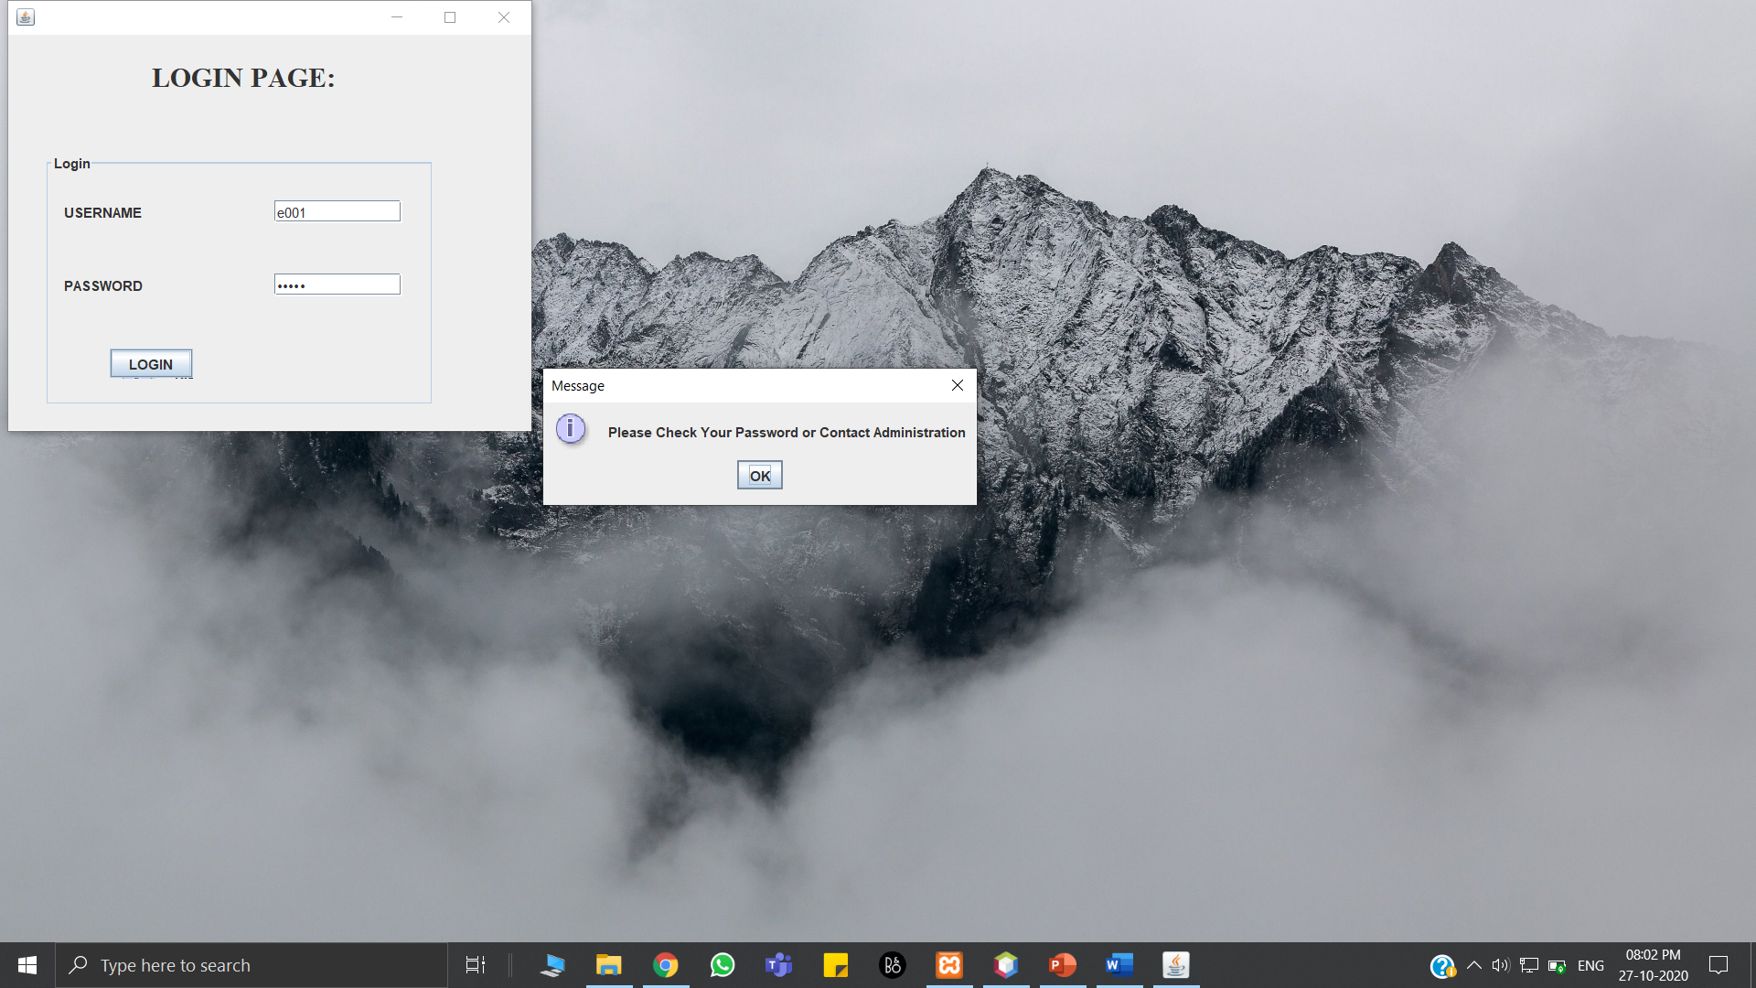

Figure 16: Invalid Credentials Error Message

This Figure 16 shows the error message when password is incorrect.

1. BACK-END SCREENSHOTS:

Figures 17 to 27 show all the tables that are there in the database for the Faculty Review System. The whole database has been created using MySQL commands.

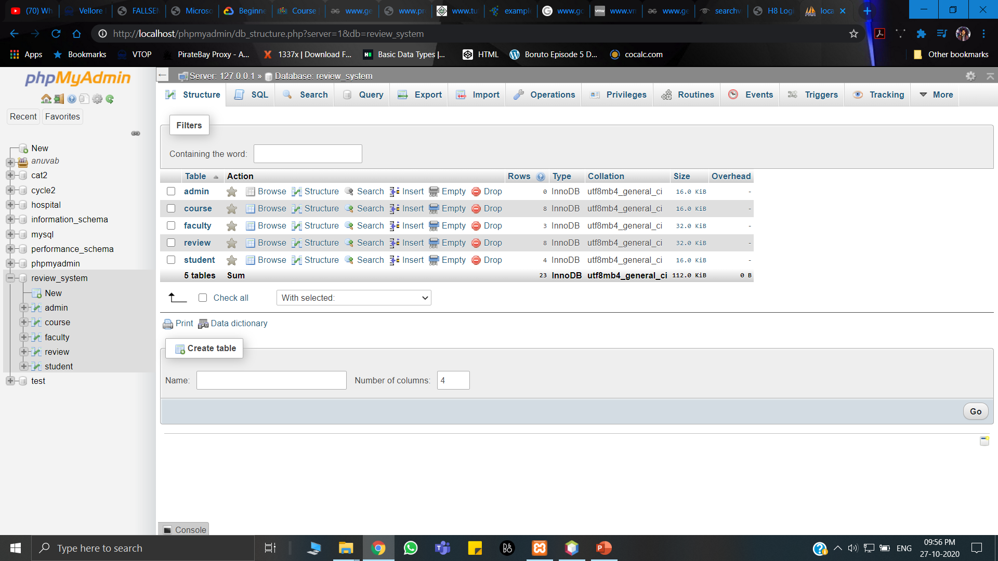

Figure 17: Overview of all tables

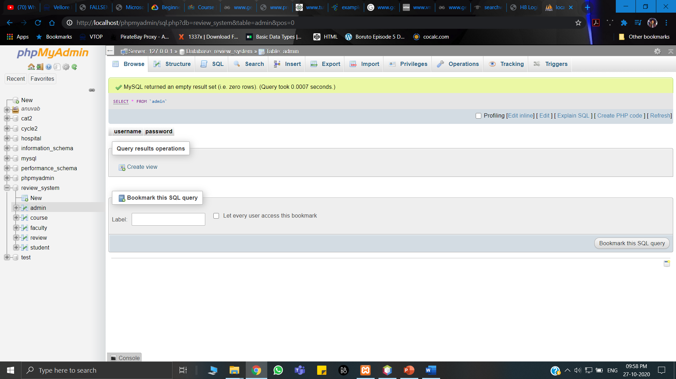

Figure 18: Admin Table

Contains Admin and Password

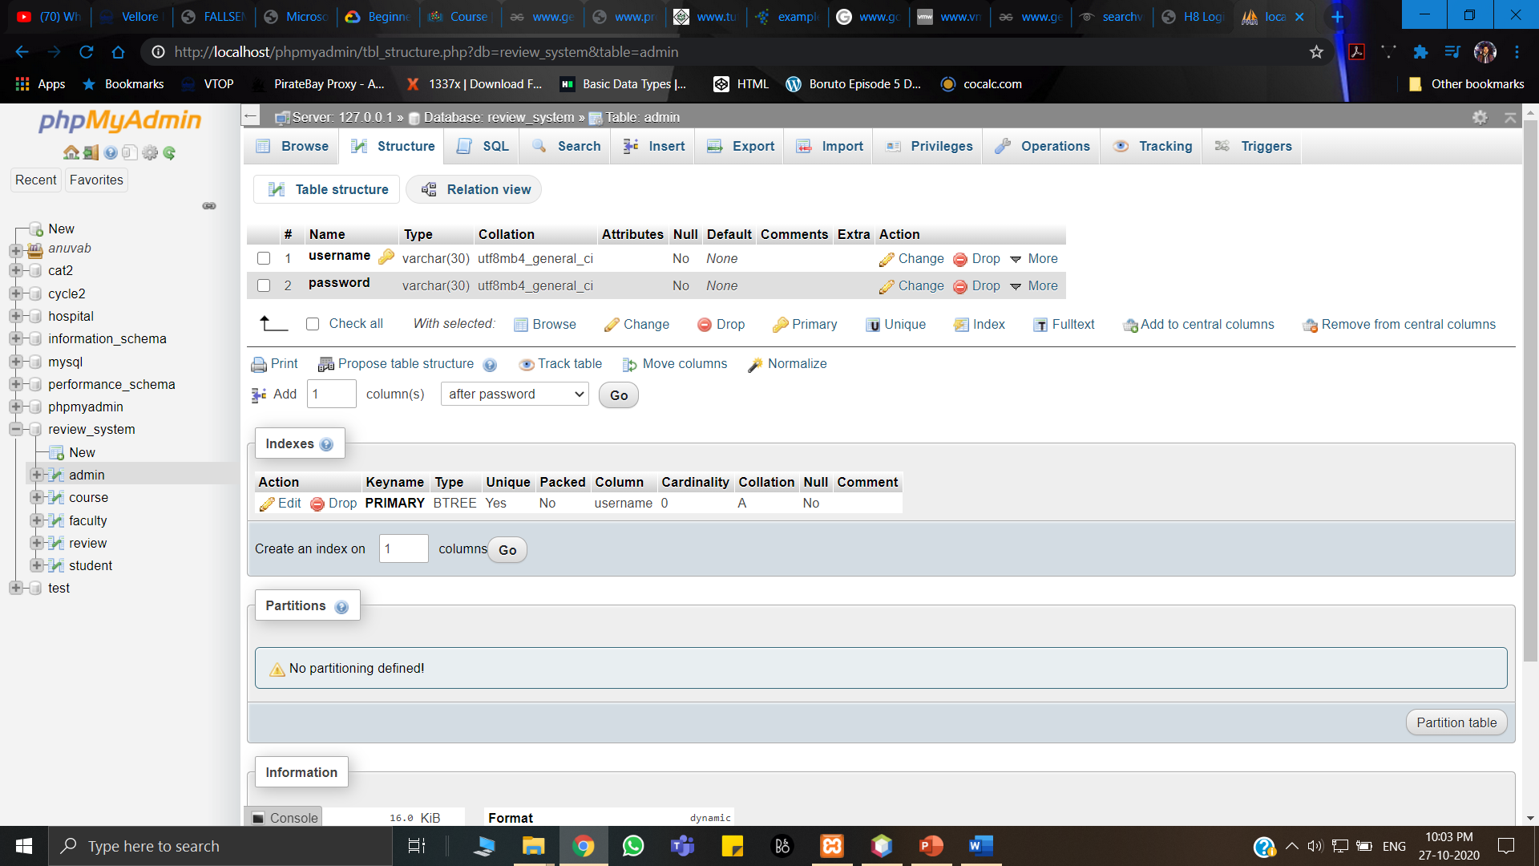

Figure 19: Admin table continued

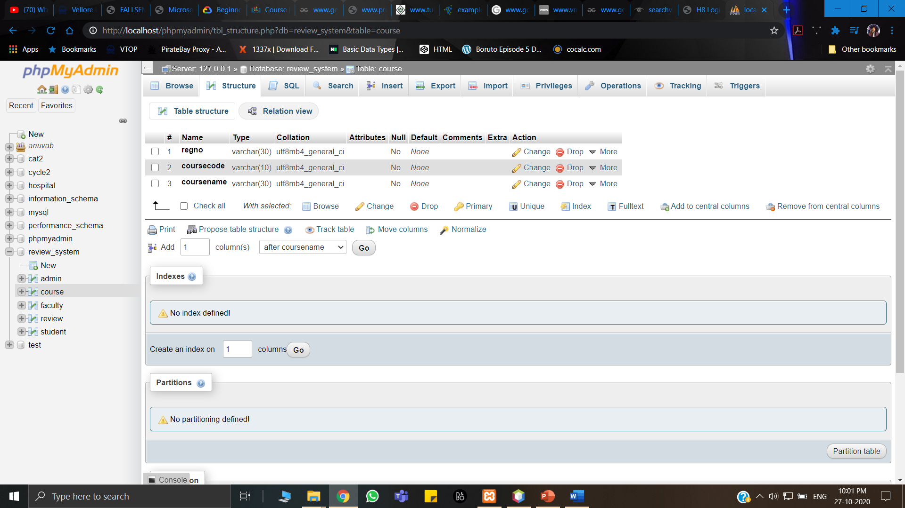

Figure 20: Course Table

Contains Students username, course code, course name.

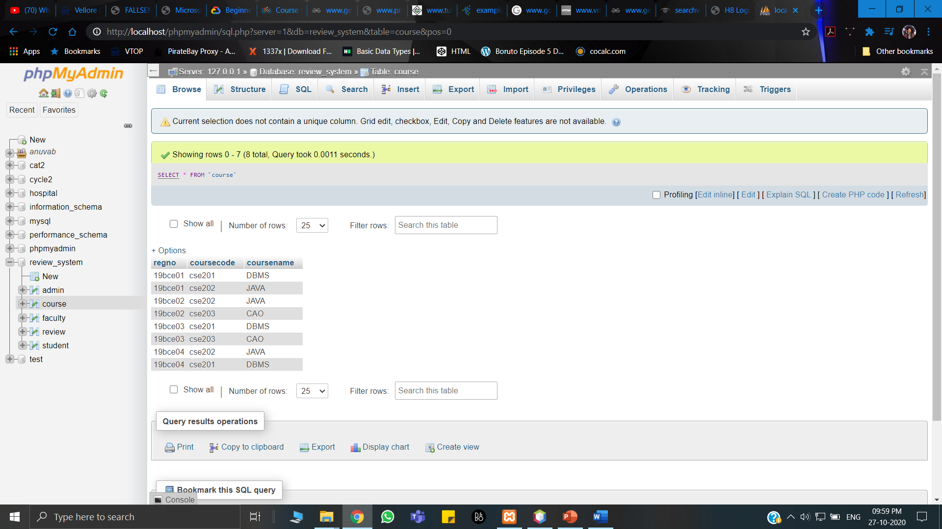

Figure 21: Course Table content

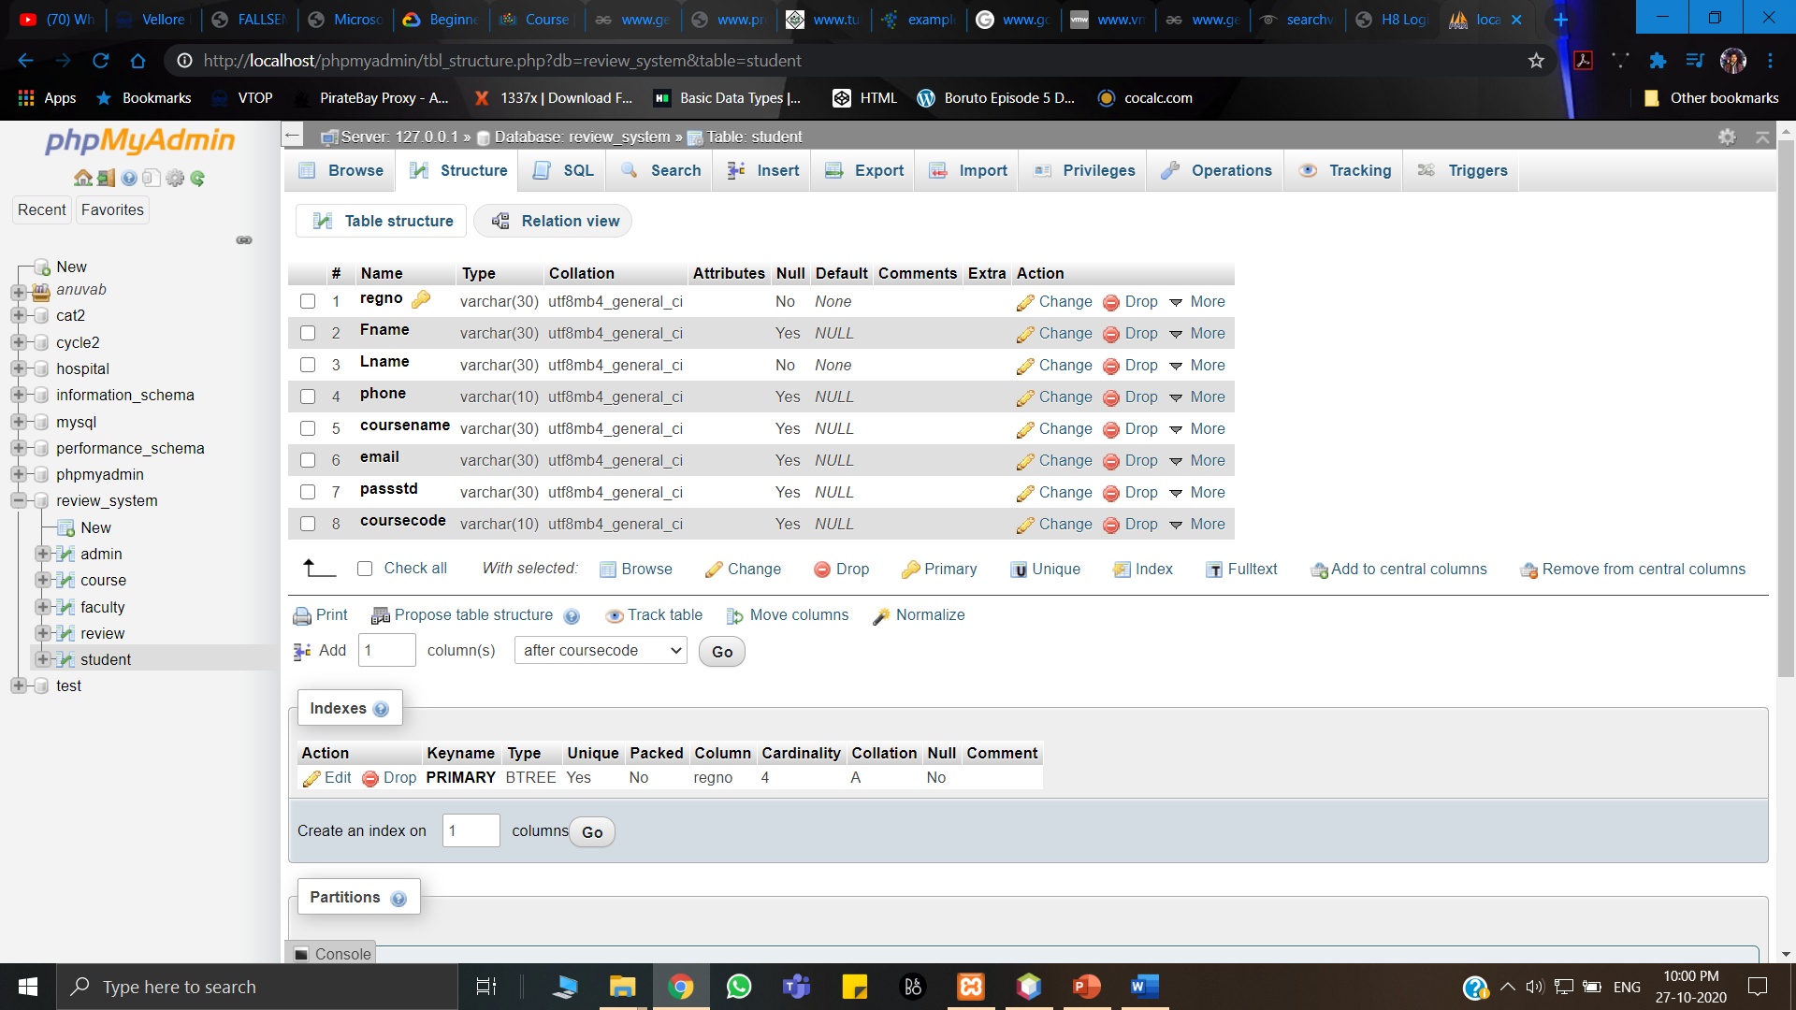

Figure 22: Student Table

Contains Student username, Password, Name, Phone number, Email ID, Course code, Course name.

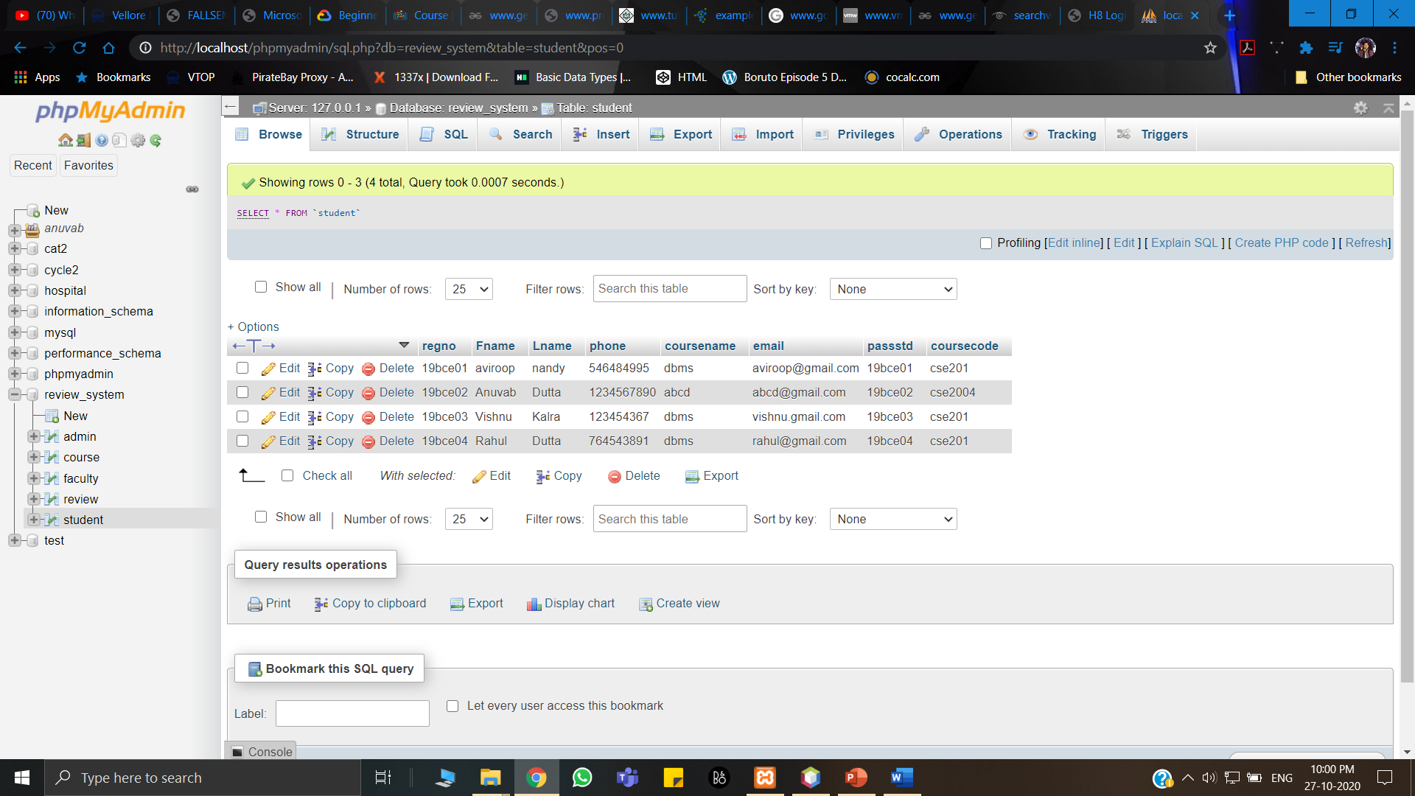

Figure 23: Student Table content

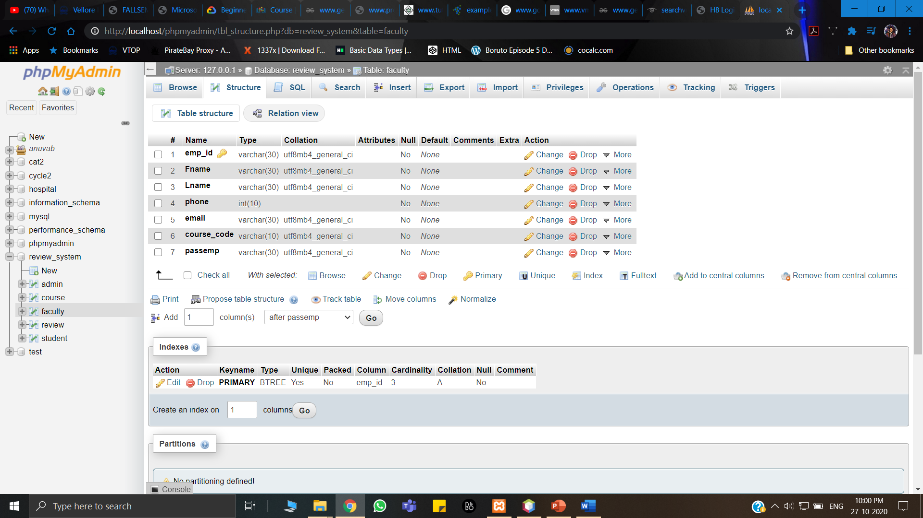

Figure 24: Faculty Table

Contains Faculty username, Password, Name, Phone number, Email ID, Course code.

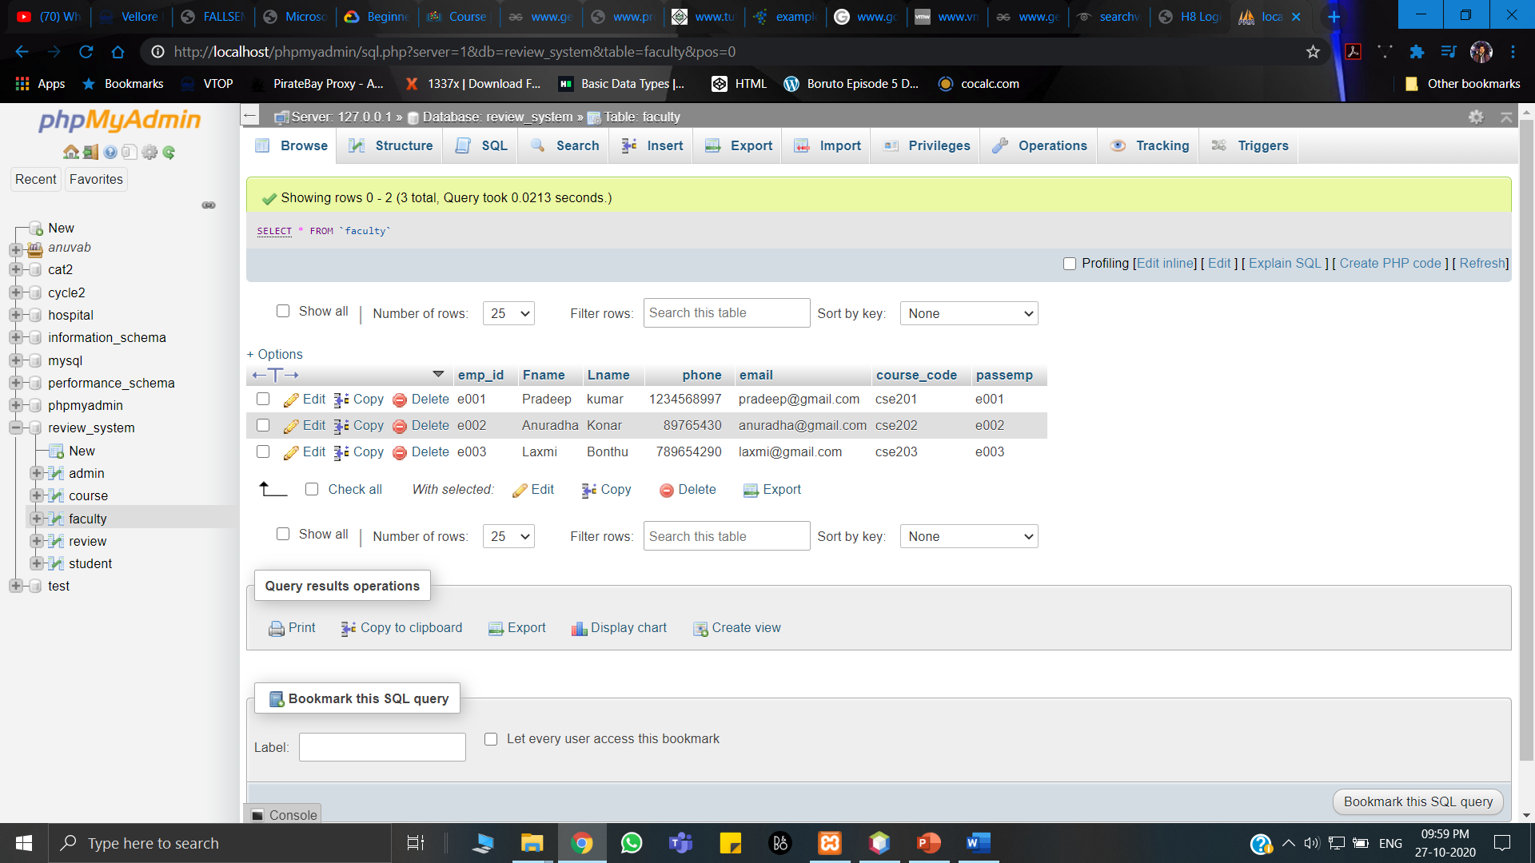

Figure 25: Faculty Table content

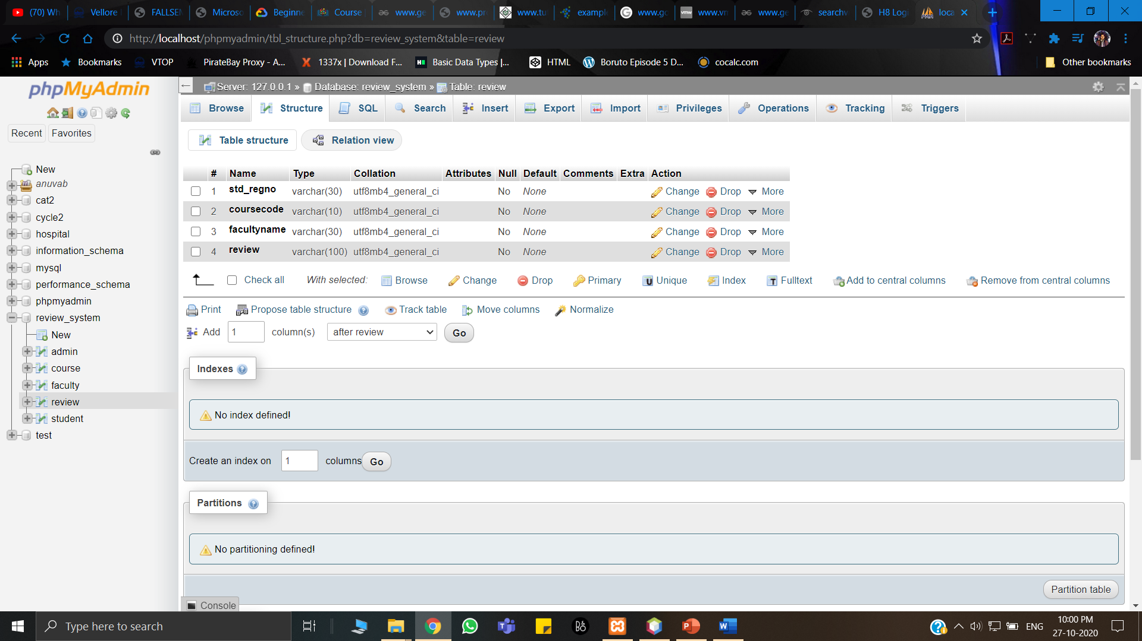

Figure 26: Review Table

This contains Student username, Faculty name, course code, Review.

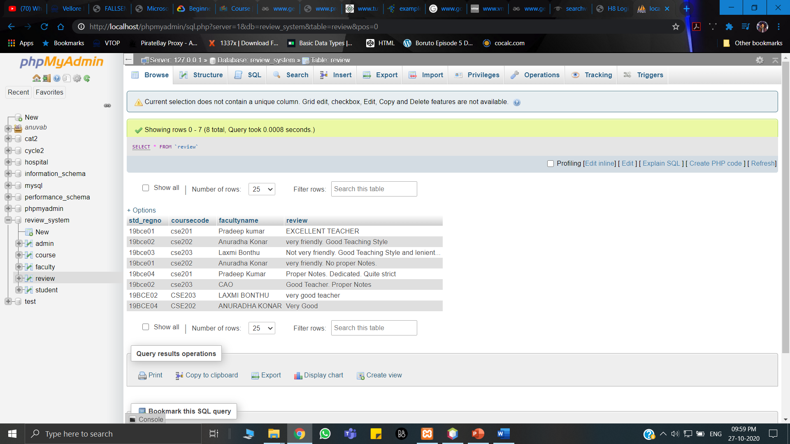

Figure 27: Review Table content

1. CONCLUSION:

Since our main goal was to give feedback to the teachers and use that feedback to do our FFCS which is course registration also known as fully flexible credit system. It will be very helpful for the students to choose their teachers whom they are quite adaptable. As mentioned in our introduction, this system is helpful in two ways one is for the student and the other is for the teacher as the teacher could change the methods of teaching accordingly.

In this project we learned new things and also how an administrator makes a database.